**Software Requirements Specification**

**Version 1.0**

**<<Annotated Version>>**

**MAY 15, 2021**

**Hotel Management System**

**\*safaa aldaher**

**\*qamar abbas**

**\*muhammad Ghayth khallouf**

**Submitted in partial fulfillment of the requirements of CS 310 software Engineering**

<<Any comments inside double brackets such as these are not part of this SRS but are comments upon this SRS example to help the reader understand the point being made>>.

Refer to the SRS Template for details on the purpose and rules for each section of this document.

# Table of Contents

Table of Contents i

List of Figures ii

1.0. Introduction 1

1.1. Purpose 1

1.2. Scope of Project 1

1.3. Glossary 2

1.4. References 3

1.5. Overview of Document 3

2.0. Overall Description 3

2.1 System Environment 4

2.2 Functional Requirements Specification 4

2.2.1 admin Use Cases 4

Use case: manage booking 5

Use case: manage gallery 5

Use case: manage hotels 5

Use case: manage users 5

Use case: manage facilities 5

Use case: manage emails 5

Use case: manage pages 5

2.2.2 customer Use Cases……………………………………………………………………………..6

Use case: search room or event 6

Use case: booking 6

Use case: login 6

Use case: register 6

Use case: read offer 6

Use case: buy cuopon 6

**2.2.3 Receptionist Use Cases 6**

Use case: De-reservation 7

Use case: Add customer 7

Use case: manage rooms 7

2.2.4 administrative Admin Use Cases 8

Use case: add Employee 8

Use case: Delete Employee 8

Use case: modify Employee Data 8

Use case: Give Requital 8

Use case: Add Discount on the salary 8

2.2.5 service admin Use Cases 9

Use case: Calculate the service's Amount 9

Use case: Add New Service Type 9

Use case: Add Service Resource 9

Use case: Delete Service Resource 9

Use case: Modify Service Resource Data 9

Use case: Determine Service's Cost on the Hotel 9

Use case: Determine Service's Cost on the customer 9

2.3 User Characteristics 10

2.4 Non-Functional Requirements 10

3.0. Requirements Specification 11

3.1 External Interface Requirements 11

3.2 Functional Requirements 11

3.2.2 search room 11

3.3 Detailed Non-Functional Requirements 11

Index………………………………………………………………………………………………………11

# List of Figures

Figure 1 - System Environment 4

# Introduction

The Hotel Management System is a tool for booking the rooms of Hotel through online process by the Customer. It provides the proper management tools and ease of access to the Customer Information. ..

## 1.1. Purpose

The Software Requirements Speciﬁcation (SRS) will provide a detailed description of the requirements for the Hotel Management System (HMS). This SRS will allow for a complete understanding of what is to be expected from the newly introduced system which is to be constructed. The clear understanding of the system and its' functionality will allow for the correct software to be developed for the end user and will be used for the development of the future stages of the project. This SRS will provide the foundation for the project. From this SRS, the Hotel Management System can be designed, constructed, and ﬁnally tested. This SRS will be used by the system development team which is constructing the HMS and the hotel end users. The Project team will use the SRS to fully understand the expectations of this HMS to construct the appropriate software. The hotel end users will be able to use this SRS as a "test" to see if the constructing team will be constructing the system to their expectations. If it is not to their expectations the end users can specify how it is not to their liking and the team will change the SRS to ﬁt the end users' needs.

## 1.2. Scope of Project

The introducing software, Hotel Management System which is going to be implemented for Hotel Marina will automate the major operations of the hotel. The Reservation System is to keep track in room and hall reservation and check availability. The Room Management System is for manage all room types room services. The Inventory Control System will keep track in all inventories of the hotel and guest details will handled by guest management. Administration department will monitor the all. There is three End Users for HMS. The End Users Are administrative admin, admin and Receptionist. Administrative admin can access to all system functionalities without any restrictions. admin can access to all system functionalities with limited restrictions. Receptionist can only access to the Reservation management section. To keep restrictions for each End User levels HMS can create different Login functions. The objectives of the automated Hotel Management System is to simplify the day to day processes of the hotel. The system will be able to handle many services to take care of all customers in a quick manner. As a solution to the large amount of ﬁle handling happening at the hotel, this software will be used to overcome those drawbacks. Safety, easiness of using and most importantly the efﬁciency of information retrieval are some beneﬁts the development team going to present with this system. The system should be user appropriate, easy to use, provide easy recovery of

appropriate, provide easy recovery of errors and have an overall end user high subjective satisfaction.

## 1.3. Glossary

|  |  |
| --- | --- |
| **Term** | **Definition** |
| SRS | Software Requirements Speciﬁcation ..  . |
| HMS | Hotel Management System .. |
| Rooms | This the product that the hotel will give to the customer and also event |
| admin | Who is the manager for website to manage hotel |
| Administrative admin | This the person that he add rooms and events and manage products from his control panel |
| customer | A person that he book the product room or event |
| Database | Collection of all the information monitored by this system. |
| Software Requirements Specification | A document that completely describes all of the functions of a proposed system and the constraints under which it must operate. For example, this document. |
| Stakeholder | Any person with an interest in the project who is not a developer. |
| User | Administrative Admin or customer or Admin |

## 1.4. References

IEEE. *IEEE Std 830-1998 IEEE Recommended Practice for Software Requirements Specifications.* IEEE Computer Society, 1998.

## 1.5. Overview of Document

. This SRS is organized into two parts the ﬁrst is the overall description and the second section is the speciﬁc requirement. The overall description will describe the requirement of Hotel Management System. The speciﬁc requirement section describes the detail of the system.

# 2.0. Overall Description

## 2.1 System Environment

Service Admin

HB DB

admin

customer

Administrative admin

Online website

hotel Manager

Hotel System

receptionist

Figure 1 - System Environment

***2.1 Flow chart***

The booking System has five active actors and one cooperating system. The customer, admin, Receptionist accesse the online booking through the Internet. Any admin communication with the system is through control panel. The customer accesses the entire system directly.

***2.2 Functional Requirements Specification***

Functional requirements define the fundamental actions that system must perform.

The section outlines the use cases for each of the active customers separately.

the customer, the admin , the Receptionist, the Administrative Admin and the Service admin have many Use cases where the Admin is main actor in this system.

2.2.1: admin Use Cases

In case of multiple admin, this term refers to the *principal admin*, with whom all communication is made.

Use case: admin use case

**Diagram:**

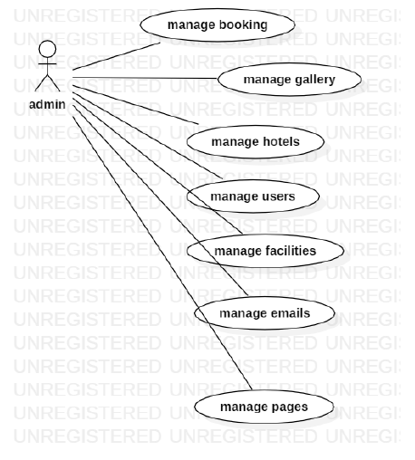

**Brief Description**

The admin confirms the booking.

**Initial Step-By-Step Description**

Before this use case can be initiated, the admin has already connected to the Online Booking System.

1. The admin chooses the *reservation to confirm it*.

2. The admin click on confirm the email will send to customer that your room confirmed.

3. The System generates and sends an email acknowledgement.

Xref: section 3.2.1, admin hotel

2.2.2: Use cases: **Customer**

Diagram:

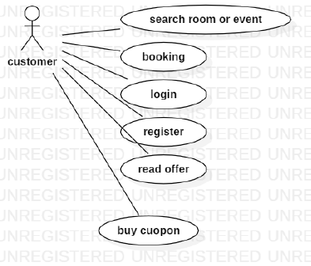

**Brief Description**

The customer accesses the Online Booking Website, searches for an room and reserve it.

**Initial Step-By-Step Description**

Before this use case can be initiated, the customer has already accessed the Online booking system.

8. The customer chooses to search by price, location, or keyword.

9. The system displays the choices to the Customer.

10. The customer selects the room or event desired.

11. The system presents the details of the order to the customer.

**Xref:** section 3.2.2,search room;

### 2.2.3 Receptionist Use Cases

**Diagram:**

Receptionist

Add customer

**Brief Description**

The confirms the booking. .

**Initial Step-By-Step Description**

Before this use case can be initiated, the Receptionist has already connected to the Online hotel Website.

1. The Receptionist chooses the *Email Editor* button.
2. The System uses the *send to* HTML tag to bring up the user’s email system.
3. The Receptionist fills in the Subject line and attaches the file as directed and emails it.
4. The System generates and sends an email acknowledgement.

**Xref:** Section 3.2.3, Receptionist

2.2.4: administrative admin use cases

**Diagram:**

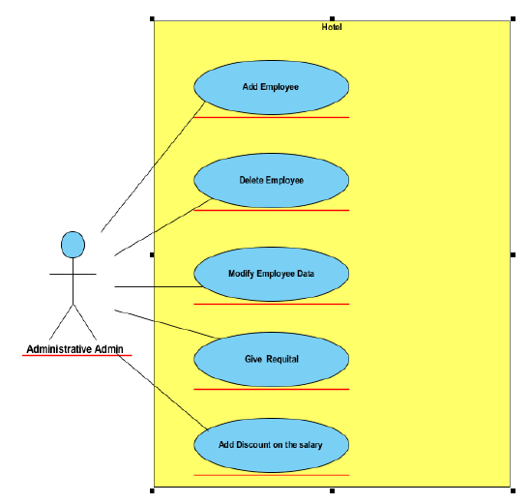

**Brief Description**

# Services provided to hotel managers: Administrative admin.

**Initial Step-By-Step Description**

# His mission is to manage the personnel affairs of the hotel, In addition to the hotel’s financial affairs department, he has the following responsibilities:

# 1- Add an employee to the working staff.

# 2- Dismissing an employee from his work.

# 3- Amending the employee's information when necessary.

# 4- Imposing penalties on an employee.

# 5- Granting a reward to an employee.

# 6- Calculating salaries of employees and disbursing them after taking into consideration (rebates) And employee rewards).

# 7- one account paid by the hotel to secure its requirements and pay taxes.

Xref: section 3.2.4 , adimistrative

2.2.5 : service admin use cases

**Diagram:**

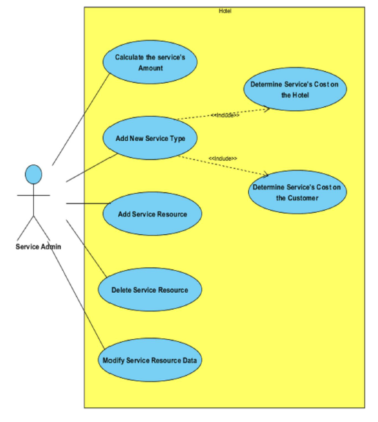

**Brief Description**

# Services provided to hotel managers : service admin

**Initial Step-By-Step Description :**

He is responsible for the services provided by the hotel and coordinating communication With the authorities that provide these services, and in detail, his mission will be:

# 1- Adding a new service at the hotel.

# 2- Calculating the available quantity of a service.

# 3- Add the service. Calculate the cost of the hotel towing

# 4- Determining the cost of the service that the customer incurs if he requests it.

# 5- Adding a new service agency to start dealing with it (company - factory - restaurant).

# 6 - Deleting a service agency the hotel was dealing with. G- Modifying the data of a service agency that the hotel deals with (location - phone numbers ..).

***Xref: section 3.2.5, service admin***

**2.3 User Characteristics :**

The customer is expected to be Internet literate and be able to use a search engine. The main screen of the Booking online system will have the search function and a link to “room details Information.”

The customer and admin are expected to be Internet literate and to be able to use chat.

The admin is expected to be Windows literate and to be able to use button, pull-down menus, and similar tools.

The detailed look of these pages is discussed in section 3.2 below.

## 2.4 Non-Functional Requirements

1. The system must ensure that all the transferable data as for examples customers credit or debit card number, CVV Code, e-payment should be done in secured connection.

2. The system must be able to handle multiple transactions a time.

3. The system must provide customers 24*7 hours online booking service.

4. The system should support almost all the browsers (Internet Explorer, Safari, Chrome, and Firefox).

5. The system should be able to convert the price from R.S to USD.

6. System should send the newsletter about ongoing promotions or deal to registered customers.

7. Customers need to cancel the booking before 24 hrs. Otherwise their credit card will be charged for one day.

8. In promotion time the system will charge credit card promptly.

# 3.0. Requirements Specification

## 3.1 External Interface Requirements

The only link to an external system is the link to the Hotel Booking (HB) Database to verify the membership of a customer. The HB Database fields of interest to the Hotel Booking System are member’s name, membership (ID) number, and email address (an optional field for the HB Database).

## 3.2 Functional Requirements

### 3.2.2 search Room

|  |  |
| --- | --- |
| **Use Case Name** | Search room |
| **XRef** | Section 2.2.2, Search room SDD, Section 7.1 |
| **Trigger** | The customer assesses the hotel booking Website. |
| **Precondition** | The Web is displayed with grids for searching. |
| **Basic Path** | 1. The customer chooses how to search the Web site. The choices are by price, by Category, by location, and by Keyword. 9 2. If the search is by Keyword , the system creates and presents an alphabetical list of all Keyword in the database. In the case of a hotel with multiple rooms, each is contained in the list. 3. The customer selects an room. 4. The system creates and presents a list of all room by that location in the database. 5. The customer selects an room. 6. The system displays the details for the room. 7. The customer selects to book the room or to return to the room list or to the previous list.. |
| **Alternative Paths** | In step 2, if the customer selects to search by category, the system creates and presents a list of all categories in the database. 3. The customer selects a category. 4. The system creates and presents a list of all rooms in that category in the database. Return to step 5. In step 2, if the customer selects to search by keyword, the system presents a dialog box to enter the keyword or phrase. 3. The customer enters a keyword. 4. The system searches the details of rooms with that keyword and creates and presents a list of all such rooms in the database. Return to step 5. |
| **Postcondition** | The selected room is reserved. |
| **Exception Paths** | The customer may abandon the search at any time. |
| **Other** | The categories list is generated admin . |

## 3.3 Detailed Non-Functional Requirements

1...The system supports customers booking and able to modify them

2…Customers can search based on hotel, apartment, inns .

3…When a customer search for hotels, apartment, and the search result must contain hotel or apartment information (Address, Ratings, and Price) and also its availability within choosing check in and checkout date.

4…Customers able to cancel their booking from their account.

5…Staffs able to edit customers booking information (updating check in, check out, room preferences, bed preferences and also cancelling booking).

6…Customers can book online and pay with credit or debit card.

7…The system must send booking confirmation email after successful payment

8…Customers can write reviews about hotels and apartment and also rate them.

9…Customers able to check their booking status from their individual account.

10…Customers can send feedback or call the company for booking purposes.

11…Customers can check for latest promotion or deal.

# Index

Abstract, 6, 7, 12

add, 9, 11

Room 1, 5, 6, 7, 8, 9, 10, 11, 12

Hotel Manager, 5, 8, 9, 10, 11, 12

customer, 1, 4, 5, 6, 7, 8, 9

Database, 2, 9, 12

admin, 1, 4, 5, 6, 7

Receptionist 1,12,2

Administrative Admin 2,7,8

Service Admin 12,1,3

Hotel System 4,12,1

Online Website 2,3,12